Safeguarding the Open Green Fields of Hollin Busk for the Benefit of Future Generations – Reasons for Refusal of Appeal APP/J4423/W/21/3267168.

Friends of Hollin Busk
February 2021

Contents
1. Introduction.
2. Local Feeling and Expectations.
3. Sheffield Planning Policy.
4. Sheffield City Council policy.
5. Local History and Landscape Impact.
6. Sustainability.
7. Ecology.
8. Heritage.
References.
Photographs.

Safeguarding the Open Green Fields of Hollin Busk for the Benefit of Future Generations – Reasons for Refusal of Appeal APP/J4423/W/21/3267168.

1. Introduction.
Friends of Hollin Busk have already presented 7 documents (refs 1-7) objecting to this application which are on the Sheffield Planning website. This is in addition to individual objections from FoHB members. It is assumed that these have already been consulted. This document concentrates on new aspects or updating on previous points and hence attempts to avoid wholesale duplication. It does cover all the main points that FoHB believe to be relevant to the Public Inquiry.
2. Local Feeling and Expectations.
Stocksbridge is a steel town 12 miles north west of Sheffield that is emerging from its industrial past, but still has an important special steels industry supplying world markets. It is in a valley and is surrounded by open countryside with the Pennines and reservoirs on its western flank and the area is rather a “hidden gem” popular for exercise and recreation that is often overshadowed by the well-known Peak District.
Hollin Busk is located towards the top of the hillside south of Stocksbridge but is part of a green space separating the town from the upper part of Deepcar. There have been previous attempts to build on Hollin Busk and local people’s common understanding is that it has been given special protection as Open Countryside and will not be built upon. They quote Sheffield Core Strategy 2009 CS72 Protecting Countryside not in the Green Belt “The land at Hollin Busk is a large and integral part of the countryside south of Stocksbridge, prominent in local views and providing an important visual break between the settlements of Stocksbridge and Deepcar. Its rural character is greatly valued locally and there is no need to develop it, as new housing can be provided on previously developed land within the urban area. Indeed, protection of the area makes a significant contribution to the character and distinctiveness of Stocksbridge”.
The recent application 17/04673/OUT for urban expansion into open countryside provoked a huge community response and the local action group Friends of Hollin Busk (FoHB) was formed in 2017 to contest this application. Local people are incensed that another attempt has been made to build on this land. There was no community consultation or public meeting and no discussion with the Town Council on what was known to be a very sensitive issue. FoHB commenced a publicity campaign involving site posters, 2,500 leaflets, social media, press articles. We gained the support of our local MP Miriam Cates, our Sheffield City Councillors Julie Grocutt and Francyne Johnson, Stocksbridge Town Council, the Campaign for the Protection of Rural England, Sheffield and Rotherham Wildlife Trust and Bolsterstone Community Group. The application has been hanging over the heads of local people for 4 years with several postponements and delays in management of the case. When the application eventually went to the Sheffield Planning and Highways Committee in July 2020 it had 528 objections and was refused by 12 votes to 1. A significant victory for the local people.
Local people appreciate the amenity of this green open space that has tremendous views across the valley and of sunsets in the west. The open character of the area adjoins to the Green Belt, that starts on the other side of Hollin Busk Lane, and then on to the Peak District (see appended photos). Hollin Busk is a flat area, in this hilly local terrain, that is popular for walking, horse riding and is a regular route for school children walking to the 2 nearby schools, Stocksbridge High School and Royd Preparatory and Infants School. It is a regular route for cars to the local shops and amenities in Stocksbridge that are 1.2 miles away.
Local people have for many years wanted this land put into the Green Belt but the LPA in 2007 stated that this required a full review of the Green Belt that was not possible as the Core Strategy was imminent and therefore Hollin Busk was given protection as Open Space. With a Green Belt Review currently underway, now is the time to put Hollin Busk in the Green Belt.
3. Sheffield Planning Policy.
An earlier application 89/03538/OUT was submitted in 1989 and was refused in 1990 by the LPA and this decision was upheld on appeal to the Secretary of State on the grounds of a detrimental impact on the quality of the environment of the area.
An application to build a house in the grounds of Royd Cottage, which is immediately next to the Hollin Busk site, was refused and the decision upheld on appeal in 2009 (APP/J4423/A/09/2095075) on the grounds that it was “harmful to the character and appearance of the area.
Sheffield Core Strategy 2009 clearly gives protection to Hollin Busk “The green, open and rural character of greenfield land south of Stocksbridge at Hollin Busk with be safeguarded through protecting it as open space”. The Core Strategy also gives it protection in CS72 from “development for urban land use until 2026”.
Sheffield is currently in the process of developing its Local Plan but until that is produced the relevant policy is still the Core Strategy 2009 and how that aligns to more recent national policy such as the NPPF. The NPPF seeks to protect green spaces and states that older policies should not be considered out of date simply because they were adopted prior to publication of the NPPF. FoHB believes that Sheffield Core Strategy policies CS23, CS24, CS33 and CS72 are closely aligned to NPPF 117. 118. 127, 170 and 213 and therefore should be given full weight.
Recently, Sheffield has achieved a high level of housing provision and in 2020 announced that the housing land supply figure was in excess of 5 years with the necessary margin. This negates any argument that a “tilted balance” should apply. FoHB have recently been told that a future change to government housing requirement is due in June 2021 and we note that a very recent request to delay the Inquiry date would now push it into the new housing requirement and a new 5 year figure. The figure at the time of Planning Committee refusal and also the start date of the appeal was 5.4 years. FoHB believe that attempts to argue a ”tilted balance” and “reduced weight” are not appropriate because of the close alignment of the Core Strategy with the NPPF.
The Open Space at Hollin Busk is environmentally important as it provides, together with the green link down the hillside that includes Fox Glen LWS, a green separation between Stocksbridge and Deepcar. Thereby preventing unrestricted urban sprawl across the hillside. The open green landscape then extends to the village of Bolsterstone at the top of the hill. The green separation of these communities is important to retain the character of this hill farming landscape and its ancient farming hamlets.
In a post-Covid world, where open space requirements and climate change issues are higher on the agenda, the appellant’s attempts to argue that houses should be built on protected open green fields is going completely in the wrong direction.
Other very recent applications on nearby green field sites at Wiggan Farm, Worral (Committee date 8/12/20) and Wood Royd which is only 400m from Hollin Busk (Committee date23/2/21) also involve the same appellant attempting to fill in green spaces. Both these applications have recently been refused by the Sheffield Planning Committee demonstrating a consistent approach and adherence to City Council policy of minimising building on open green spaces.

4. Sheffield City Council Policy.
Sheffield City Council has adopted a policy of brownfield development first. The regeneration of old industrial sites in an industrial city like Sheffield is a principle in which we all believe. This was reiterated in a full council vote in the summer of 2019 that Sheffield’s future growth strategy would continue to be the redevelopment of brownfield sites and not the expansion into open countryside. The leader of Sheffield Council was quoted in the Sheffield Telegraph on 3/10/19 “Building on the Green Belt should be an absolute last resort. We are proud of being the greenest city in Europe and with the climate emergency, green spaces are even more important to people than they were 3 years ago”.
The Upper Don Valley has been identified as an area suitable for new housing and 3 good examples of, large, new housing developments to provide around 1000 new homes on reclaimed brownfield land are underway in the Don Valley below at Fox Valley, Warncliffe Park Deepcar, and the old paper mill site at Oughtibridge. This is a significant contribution to new housing stock in the area, that does not involve the destruction of green landscape.
A proposal to build houses on Hollin Busk is not in the Sheffield Housing Plan and is an opportunistic application that does not fit with the declared strategy of the City Council.
Sheffield, the outdoor city, has adopted a policy of green networks. CS73 The Strategic Green Network states: “within and close to the urban areas a strategic green network will be maintained, and where possible enhanced, which will follow the rivers and streams of the main valleys including a. Upper Don…..”. “These green corridors will be complimented by a local network of more local green links and desired green links”. Stocksbridge and Deepcar are separated by a green link up the hillside that includes the fields at Wood Royd, the Local Wildlife Site at Fox Glen that in turn lead on to the open green fields of Hollin Busk and then to the Green Belt and to Bolsterstone and the Peak District National Park. The appellant has submitted applications to build on 2 of these locations. The Hollin Busk site sits directly above Fox Glen, which is a very steep clough, and the application would totally isolate this LWS and sever its access to open country. This is contrary to City Council Policy and contrary to the NPPF which seeks to protect open green spaces. There is strong local feeling, and local people want to retain this green link that contributes to the open countryside appearance and distinctiveness of the area. The open green fields of Hollin Busk around Royd Farm are an important part of local heritage that are enjoyed by all.

5.Local History and Landscape Impact.
Stocksbridge is situated in a steep sided valley and the historical landscape was one of farms spaced at regular intervals along the tops and sides of the valley at the spring lines, with a corn mill located in the valley bottom. Industrialisation involved a textile mill built in the valley that would later be bought in 1842 to be the start of Samuel Fox’s steelworks. Stone quarries, gannister mines and coal mines also developed on the valley sides to supply the steel industry. Liberty Speciality Steels is still an important world player in the supply of specialised steel to the aerospace, power generation, automotive and engineering industries.
Royd Farm is one of the original farms from early times, possibly 17th century in parts, that farmed the green fields of Hollin Busk. The application seeks to surround the buildings of Royd Farm on 3 sides removing any connection with its associated green fields. Royd farm is identified on OS Maps and is a commonly known landmark and one of the oldest buildings in the area.
There are tremendous views from Hollin Busk Lane across the green fields towards Hunshelf Bank on the opposite side of the valley. The value to the community is the visual amenity afforded by its open character and appearance and is enhanced by people being able to walk along the road bordering the site. The road is a popular walking and cycling route as well as for commuter access. The proposed development would cause significant harm to the open character of the area.
Local people want to retain the distinctiveness of the individual communities of Stocksbridge, Deepcar and Bolsterstone and avoid assimilation into one continuous urban sprawl. The open character of Hollin Busk is at the triple point meeting of these 3 communities and is key to providing green separation and maintaining an open hill farming landscape. The Hollin Busk fields are still used for agricultural activities despite the appellant stating otherwise (see attached photographs).
The suggestion by the appellant that the visual impact of new housing “will be minimal” is incorrect. A change from agricultural to built development is a high magnitude change that will profoundly affect the local landscape. The visual impact, both in the immediate vicinity, from the hill above to the south, and from across the valley, would be significant. The impact on Hollin Busk does not align with NPPF 118 and 170.
6. Sustainability.
The proposals for the Hollin Busk site do not support sustainability as outlined by the NPPF and the LPA have already agreed that the site is “not ideally located from a sustainability perspective”. The site is about one mile up the hill from the main road in the valley bottom and just over a mile from the main shopping and local amenities in Stocksbridge which are again down the hill in the valley bottom. Due to the terrain and travel distances, it inevitably requires people to use cars. The area is poorly served by local buses and commuting to work in the area is commonly by car. The steepness of the terrain leaves cycling possible only for the very fit.
Traffic congestion issues are a major concern of local people. The proposed new access to the site would be a new junction on Carr Road virtually opposite Royd Preparatory and Infants School. At school drop-off and pick-up times cars are parked on both sides of the road for over 200m in both directions and the area is extremely congested. Placing a new access road for construction traffic and future residents in the middle of this regular activity would significantly heighten the road safety risk for parents and young children.
Traffic volumes down Carr Road are already high during rush hour periods as this is the main route to access main roads to Sheffield, Stocksbridge Bypass and the M1. There are already regular tailbacks at the junction with Manchester Road at the bottom of the hill where Carr Road joins the main road just before the traffic lights and cars have to rely on drivers on the main road allowing them to join the queue. Traffic surveys have identified that traffic is already over capacity at peak times. The new housing development of around 400 houses at Deepcar Warncliffe Park will also be contributing to increased traffic flow in the future. The proposal to accommodate the increased traffic by “sequencing the lights” is not a rigorous solution as the junction is already over capacity at peak times.
Hollin Busk is poorly located for access to main routes and people will have to use cars. The other new housing developments on brownfield sites in the valley bottom are much better locations for access to main routes and local amenities. Hollin Busk is an opportunistic application in an inappropriate location that does not support sustainability.
There are regular issues with flooding due to surface water run-off and bursting of drains on Carr Road partly associated with the steepness of the terrain. In periods of heavy rain, water run-off across the surface of the fields of Hollin Busk is significant and this all channels into Clough Dike and through Fox Glen LWS. The water runs into a culvert under Wood Royd Road that is 20m deep and is a well know problem to the Town Council as it regularly blocks and has caused flooding of local houses (2019). Twice in the past 6 months auxiliary pumps have had to be used to lower water levels to prevent flooding. The surface water on Hollin Busk fields currently has opportunity to soak away although in periods of high rain it can be seen flowing on the surface. The location of a housing development with associated hard surface drainage, even with a SUDS system, immediately above Fox Glen is of concern as water flow management in the Glen is being controlled for nature conservation reasons (willow tit project).
Underground water flow in this area is undoubtedly influenced by early ganister and coal mining activity but the exact nature of this is unknown.
7. Ecology.
The open green fields of Hollin Busk are a species-rich grassland that are an attraction to many forms of nature. Small mammals are abundant with fox and hedgehog regular visitors and it is a feeding ground for birds and small mammals many of whom are resident in nearby Fox Glen. Tawny Owl, Sparrow Hawk, Pheasant, Grey heron are regularly seen, and bats are commonly observed around the buildings of Royd Farm in summer months. Nesting lapwings and curlew are seen in the fields (see photographs). These fields are located immediately above Fox Glen and are the only direct access for wildlife from the Glen to open countryside. The proposed development would sever this access.
Fox Glen is a designated Local Wildlife Site and is a wooded clough of environmental importance that was gifted to the local people. This green oasis in Deepcar is used by many nesting birds and bird surveys (one of the most recent being the 8th March 2017 by Steel Valley Project) have noted a wide range of species. Fox Glen is regularly used by walkers and school children for nature study. Steel Valley Project have recently been involved in a funded project to develop the right habitat to encourage a local population of the rare willow tit. This has involved the control of water flow using a system of leaky dams. The bottom end of the Glen contains a small children’s play area but the top of Fox Glen, which is also known as Clough Dyke, is a quiet wildlife sanctuary that would be immediately adjacent to and overlooked by the proposed new housing and hence its function as a quite wildlife sanctuary destroyed.
Several people have recently been seen in the fields who when questioned said they were undertaking bird surveys for the appellant, the most recent in February 2021, but these are in winter months when many bird species are “on their holidays” and so the surveys will be of limited value.
Stocksbridge has several examples of green links that extend up the hillsides to open country. One of the best examples of these is the link that includes Wood Royd fields, Fox Glen LWS and Hollin Busk fields whose direct access to the Green Belt and open countryside would be severed, at the top end, by the proposed development.

8. Heritage.
Royd Farm and the original barns and buildings are grade 2 listed and now comprise 4 separate, private dwellings. Part of Royd Farm is believed to date back to the 17th century, with a later addition built on in the 18th century. The original front door entrance is now an internal doorway feature in the middle of the house. The farm also comprised the surrounding fields including those to the west which is the land subject to this application. Royd Farm itself has a small paddock that now contains a vegetable garden and fruit trees and has 2 distinguished and listed pig sties. There is a field gate giving direct access to the neighbouring fields.
Royd Farm is one of the oldest buildings in the area and was one of the original farms that are located at regular intervals along the hillsides. There are open views of the countryside to the West, North and South – the sunsets in the west can be tremendous. It is part of the heritage landscape that was in existence before the town of Stocksbridge, and the industrial buildings in the valley bottom, were built. By its very nature, and reason for existence, Royd Farm is associated with green fields. To “box it in” on three sides by proposed housing will totally destroy its setting.
UDP BE15 states:- “Buildings and areas of special architectural or historic interest which are important part of Sheffield’s heritage will be preserved….” “Development which would harm the character or appearance of listed buildings…..will not be permitted”.
UDP DR5 Development in Open Spaces states:- “development in open spaces will not be permitted where….(e) it would harm open space which forms the setting of a listed building or other historic building or is needed to maintain an important view or vista”.
The setting of Royd Farm is strongly linked to its surrounding green fields with a highly visible connection between the farm and the surrounding countryside. Clearly to totally isolate a grade 2 listed farm complex by converting the fields on three sides to a housing estate does significantly compromise the setting and cause major harm to a heritage asset.

9. Conclusion.
Friends of Hollin Busk and local residents are appalled at this further attempt of urban expansion into open countryside at Hollin Busk. It is contrary to Sheffield City Council Policy and current Sheffield Planning Policy and the NPPF. We urge the Planning Inspector to refuse the appeal.

Author: Dr Peter Morgan B.(Met)Hons, C.Eng, FIMMM.
Chair, Friends of Hollin Busk. February 2021.

References.
Documents from Friends of Hollin Busk sent to the Sheffield Planning Authority Objecting to Application 17/04673/OUT.

1. Response to a request for an EIA Screening Direction on Land at Carr Road/Hollin Busk, Deepcar Sheffield. Friends of Hollin Busk 17/9/17.
2. Safeguarding the Hollin Busk Area for Future Generations. A Response Statement from a Local Residents Group to a Proposed Housing Development at Hollin Busk. Planning Application 17/04673/OUT. Friends of Hollin Busk January 2018.
3. Objection from Friends of Hollin Busk to the Updated Planning Statement (dated 5/12/18) from DLP Planning (for Hallam Land Management) regarding 17/04673/OUT. 18/2/19.
4. A Response from Friends of Hollin Busk to the Case Officers Report on Application Hollin Busk 17/04673/OUT. July 2019.
5. An Additional Response from Friends of Hollin Busk to Application Hollin Bush 17/04673/OUT – January 2020.
6. A Response from Friends of Hollin Busk to New Heritage and Ecology Reports submitted by the Applicant : Hollin Busk 17/04673/OUT. 17/2/20.
7. Summary of the Main Reasons for the Planning and Highways Committee to Refuse Application 17/04673/OUT Hollin Busk. 5 minute presentation given to the Committee Meeting 14/7/20 by Dr P C Morgan, Chair – Friends of Hollin Busk.

Photographs taken around Hollin Busk.
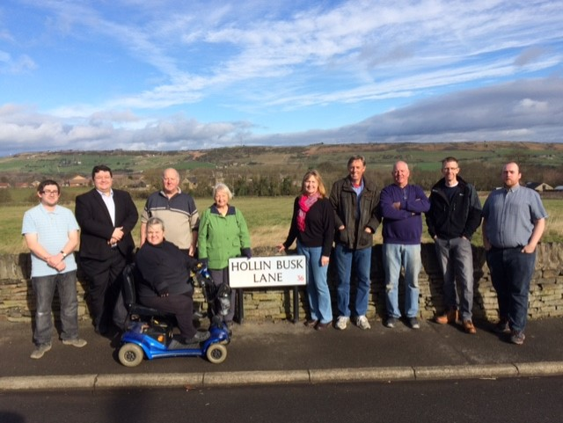Members of Stocksbridge Town Council and Friends of Hollin Busk on site. 2019
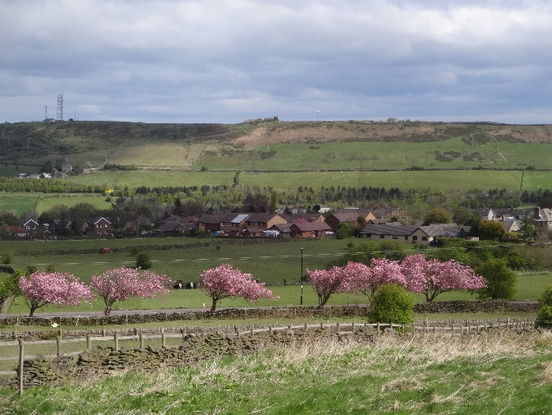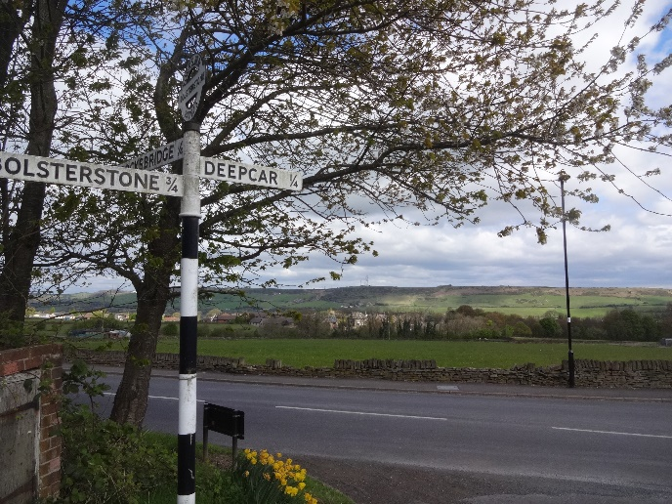Views looking north across the site and across Hollin Busk Lane.

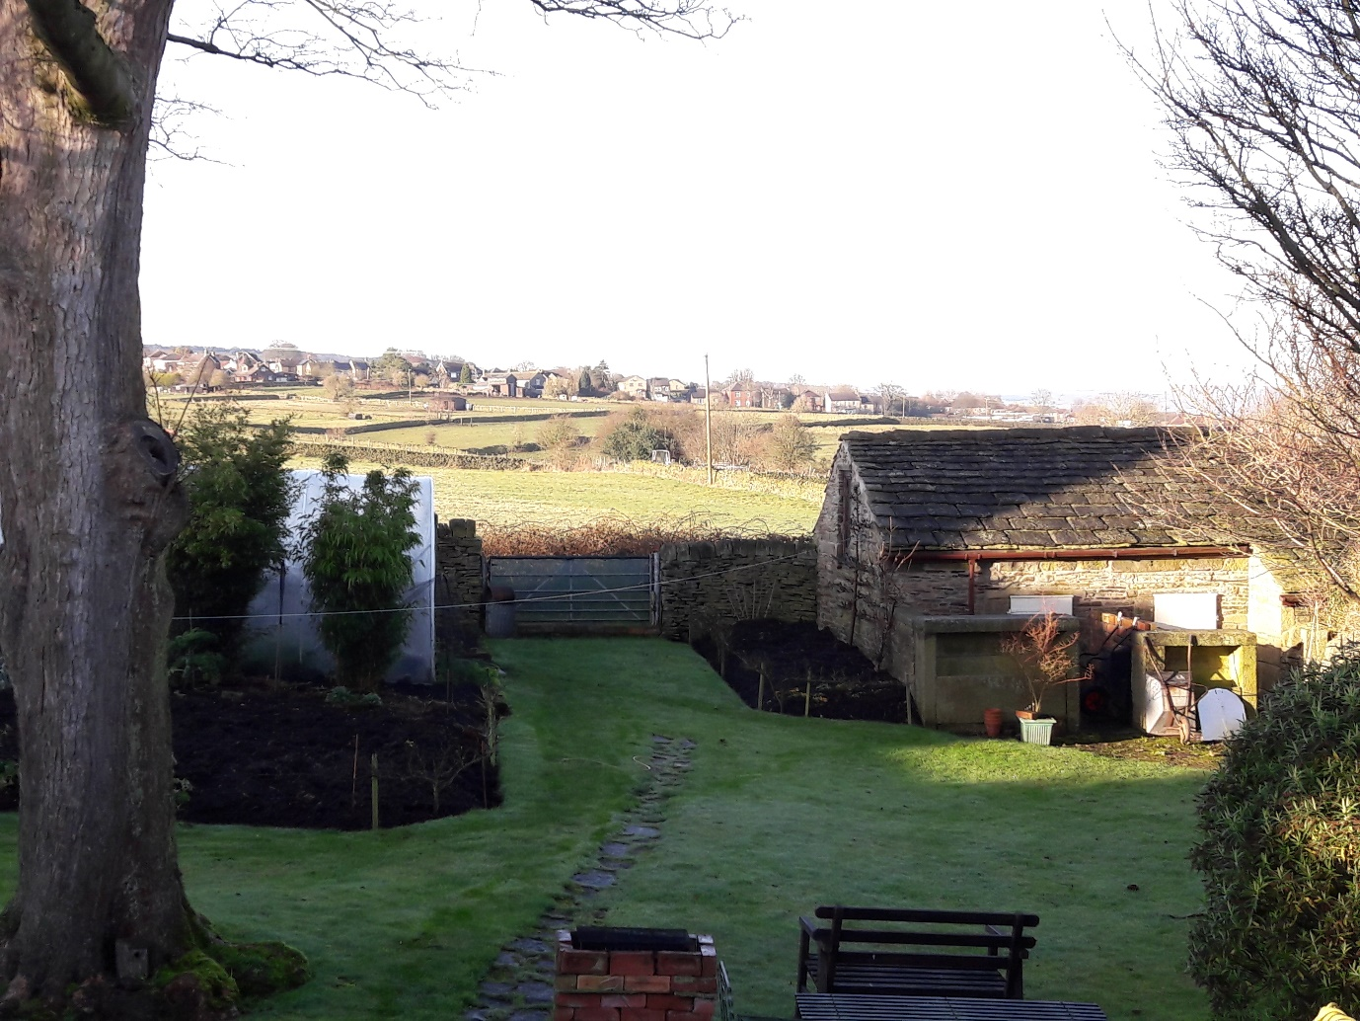View looking west from Royd Farm across the Hollin Busk fields.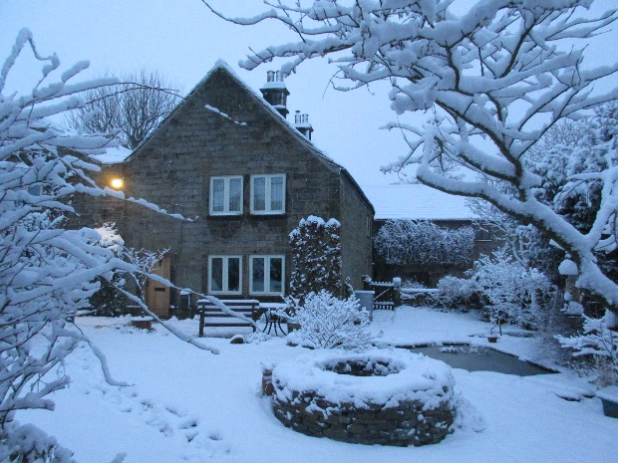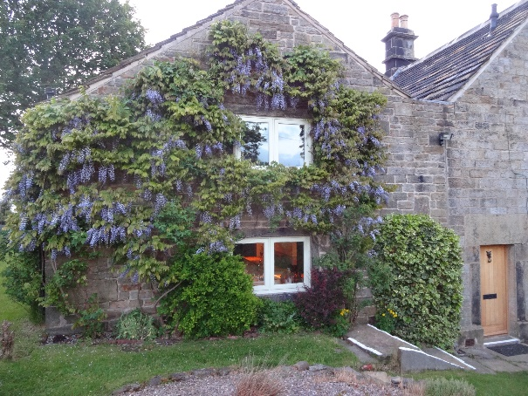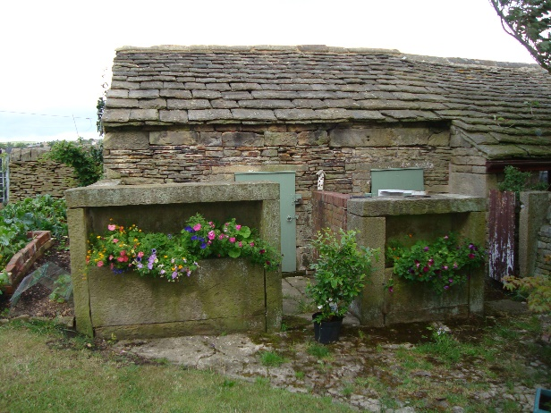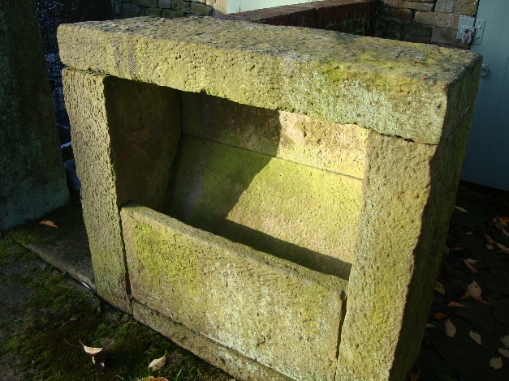
Views of Royd Farm from the front and listed pig sties at the rear.
Examples of birdlife seen on Hollin Busk fields around Royd Farm.
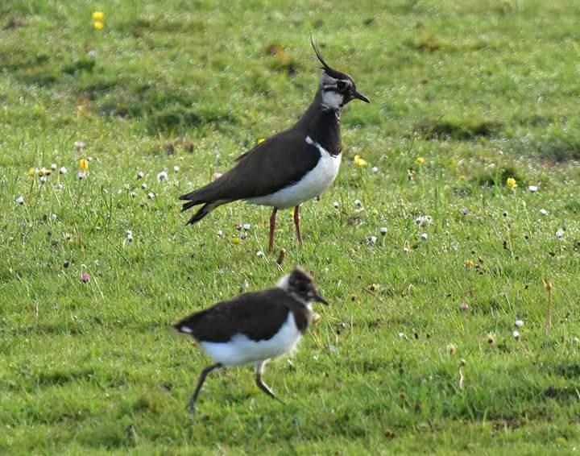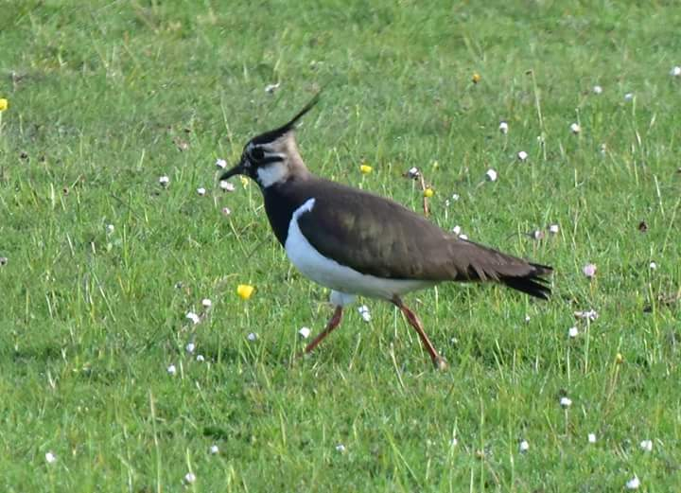
Nesting Lapwings 2017
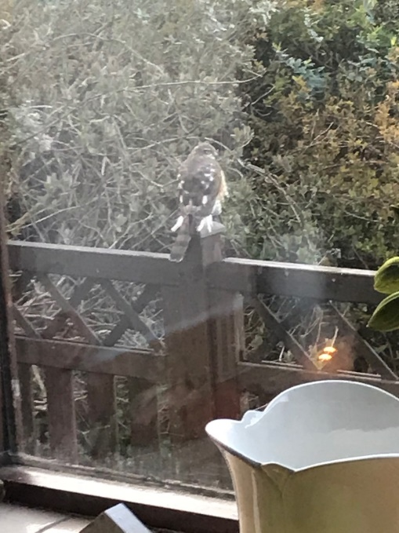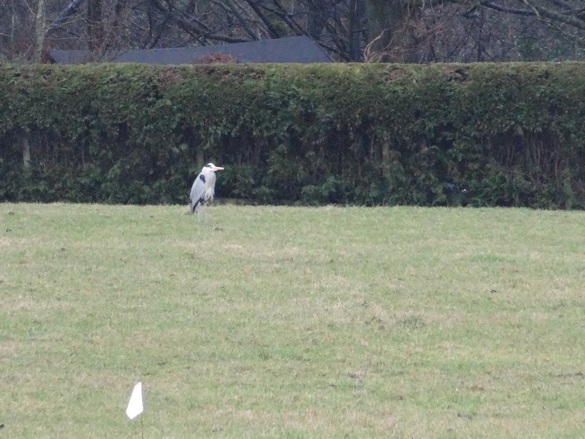Female Sparrow Hawk 2020 Grey Heron 2021

Agricultural Activities on Hollin Busk Fields 2020/2021.
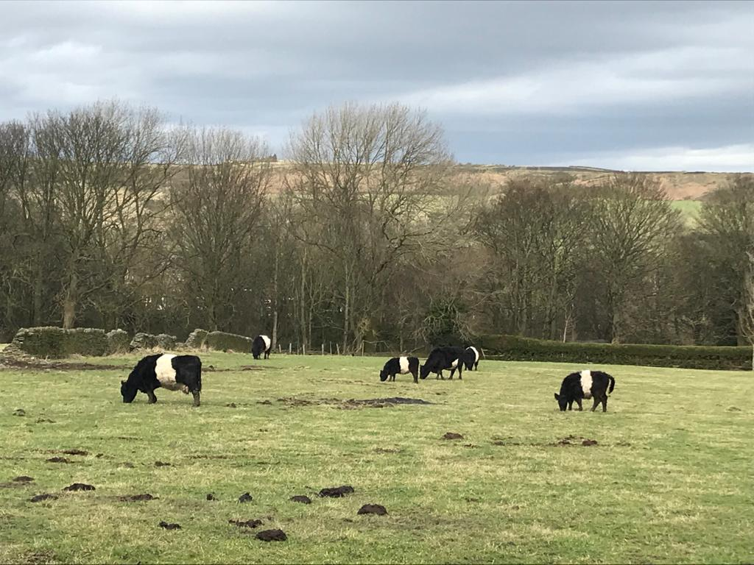
Fox Glen in the background looking north.
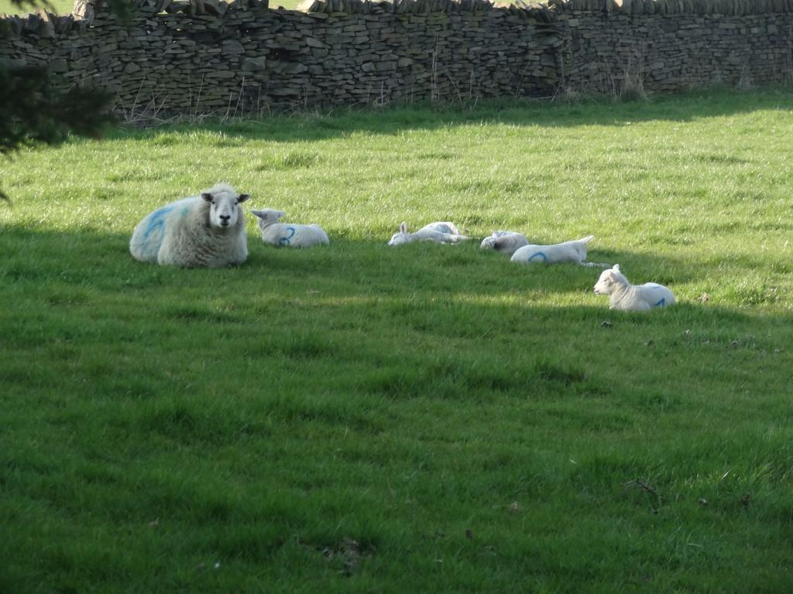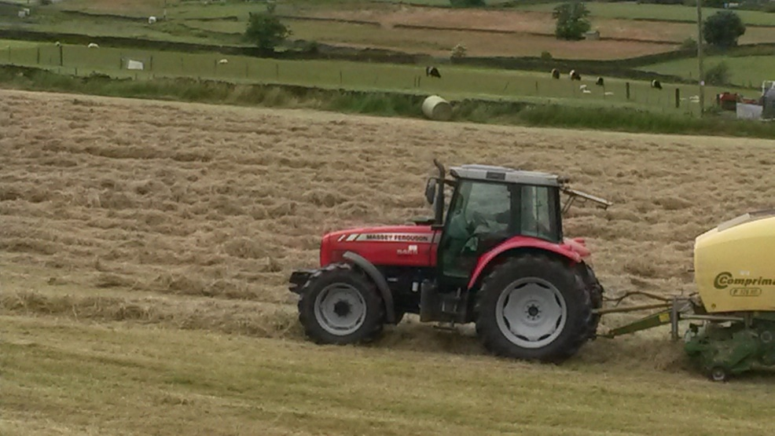
Looking west from Carr Road.

